Order Of Service

Singing: Psalm 92—CW page 101

Reading: Psalm 45

Opening Hymn: TLH 161

Reading: Acts 2:43-47

Request Hymn: CW Supplement 716

Reading: John 11:1-16

Sermon Hymn: TLH 160

Sermon Text: Song Of Solomon 7:6-7

A Palm Tree

Prayer

The Apostles’ Creed, TLH page 12

Holy Communion

The Lord's Prayer

The Blessing

Closing Hymn: TLH 644

* * * * * * * * * * *
Bible Study: Lambs: An Albatross
Sheep: Romans 1:24-32

Living Waters

Water
Of
Life

9 July 2017

W A T E R O F L I F E

Independent Christian Church—Conservative Lutheran Doctrine

Worship Service: 9:30 a.m. Bible Study: 10:45 a.m.

Larry Cooper, Pastor E-Mail address:
111 N. Ridge Road lcooper@wateroflife.cc
Coon Valley, WI 54623 Web Site:
Phone: (608) 452-2105 www.wateroflife.cc

* * * * * * * * * * * * * * * * * * * * * * * * * * *

Sermon Text: Song Of Solomon 7:6-7

A Palm Tree

* * * * * * * * * * * * * * * * * * * * * * * * * * *
Matthew 21:1-11

1 And when they drew nigh unto Jerusalem, and were come to Bethphage, unto the mount of Olives, then sent Jesus two disciples, 2 Saying unto them, Go into the village over against you, and straightway ye shall find an ass tied, and a colt with her: loose them, and bring them unto me. 3 And if any man say ought unto you, ye shall say, The Lord hath need of them; and straightway he will send them. 4 All this was done, that it might be fulfilled which was spoken by the prophet, saying, 5 Tell ye the daughter of Sion, Behold, thy King cometh unto thee, meek, and sitting upon an ass, and a colt the foal of an ass. 6 And the disciples went, and did as Jesus commanded them, 7 And brought the ass, and the colt, and put on them their clothes, and they set him thereon. 8 And a very great multitude spread their garments in the way; others cut down branches from the trees, and strawed them in the way. 9 And the multitudes that went before, and that followed, cried, saying, Hosanna to the Son of David: Blessed is he that cometh in the name of the Lord; Hosanna in the highest. 10 And when he was come into Jerusalem, all the city was moved, saying, Who is this? 11 And the multitude said, This is Jesus the prophet of Nazareth of Galilee.

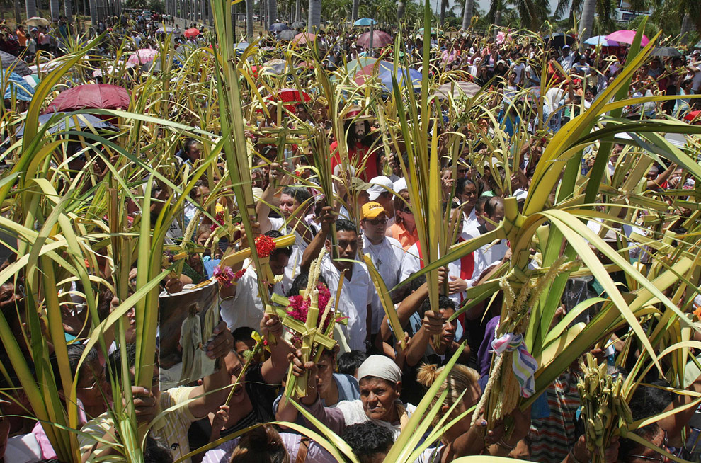

Matthew 21:12-13; 15-16 12 And Jesus went into the temple of God, and cast out all them that sold and bought in the temple, and overthrew the tables of the moneychangers, and the seats of them that sold doves, 13 And said unto them, It is written, My house shall be called the house of prayer; but ye have made it a den of thieves.

15 And when the chief priests and scribes saw the wonderful things that he did, and the children crying in the temple, and saying, Hosanna to the Son of David; they were sore displeased, 16 And said unto him, Hearest thou what these say? And Jesus saith unto them, Yea; have ye never read, Out of the mouth of babes and sucklings thou hast perfected praise?

